

CSE-3002

INTERNET AND WEB PROGRAMMING

SLOT:- L19+L20

TOPIC- HOPE: HOSPITAL MANAGEMENT SYSTEM

**FINAL REVIEW DOCUMENT**

**Submitted by:**

**HRITUJA SEN-17BCE0354**

**MIHIR KUMAR SINGH-17BCE0851**

**AVINA-17BCE0898**

**ABSTRACT:**

HOPE; our name says it all. With our project, we aim to simplify the user experience while booking appointments with doctors, or to donate blood or organs. This project works on a hospital management system, to sign up new patients and provide them the facilities for treatment or for donations. Doctors can register on our website through a form, which would then give them a unique doctor number in our hospital.

**TECHNICAL DETAILS:**

**Front-End:**

**HTML –** For structuring the User Interfaces of the website.

**CSS –** For styling the User Interfaces, Row-column layout and animation has also been implemented.

**JavaScript –** For implementing the counter on the home page.

**Back-End:**

**PHP –** For connection to database, user authentication and form validation of Sign up form.

**CODES:**

**HTML CODES:**

**index.html**

<!DOCTYPE html>

<html lang="en" dir="ltr">

<head>

<meta charset="utf-8">

<title>HOPE</title>

<link rel="stylesheet" href="style.css">

<link rel="stylesheet" href="https://cdnjs.cloudflare.com/ajax/libs/font-awesome/4.7.0/css/font-awesome.min.css">

<link href="https://fonts.googleapis.com/css?family=Alegreya+Sans+SC&display=swap" rel="stylesheet">

</head>

<body>

<div class="navbar" id="myTopNav">

<a href="apply.html" class="auth">Sign Up</a>

<a href="login.html" class="auth">Login</a>

<a href="index.html">HOME</a>

<a href="about.html">ABOUT</a>

<a href="contact.html">CONTACT US</a>

</div>

<div class="welcome">

<h1>WELCOME</h1>

</div>

<div class="head">

<h1>FORMS</h1>

<div class="row">

<div class="card">

<div class="picture">

<img src="patient.jpg" alt="pic1">

</div>

<p>Application for Patients.</p>

<hr>

<div class="btn btn-apply">

<a href="apply.html" target="_blank">Apply</a>

</div>

</div>

<div class="card">

<div class="picture">

<img src="donation.jpg" alt="pic2">

</div>

<p>Donate! Save a Life...</p>

<hr>

<div class="btn btn-donate">

<a href="donate.html" target="_blank">Donate</a>

</div>

</div>

<div class="card">

<div class="picture">

<img src="doctors.jpg" alt="pic3">

</div>

<p>Doctor? We need you!</p>

<hr>

<div class="btn btn-register">

<a href="#" target="_blank">Register</a>

</div>

</div>

</div>

</div>

<div class="spec">

<div class="row">

<h2>MULTI-SPECIALITY</h2>

<div class="col">

<ul>

<li class="header">CARDIOLOGIST <i class="fa fa-heartbeat"></i></li>

<li>Dr. Rohit Sippy</li>

<li>Heart Surgeon</li>

<li>Contact: <span class="callme">9876543260</span></li>

</ul>

</div>

<div class="col">

<ul>

<li class="header">NEUROLOGIST <i class="fa fa-user"></i></li>

<li>Dr. Deepika Kakkar</li>

<li>Neuro Surgeon</li>

<li>Contact: <span class="callme">8756432172</span></li>

</ul>

</div>

<div class="col">

<ul>

<li class="header">PEDIATRICIAN <i class="fa fa-child"></i></li>

<li>Dr. Veena Singh</li>

<li>Child Specialist</li>

<li>Contact: <span class="callme">7044165672</span></li>

</ul>

</div>

</div>

</div>

<div class="count">

<div class="row">

<h3>That's <span>US</span></h3>

<hr>

<div class="details rtborder">

<h3>No. of beds</h3>

<p id="bed"></p>

</div>

<div class="details rtborder">

<h3>Lifesavers</h3>

<p id="doctor"></p>

</div>

<div class="details">

<h3>Staff Count</h3>

<p id="staff"></p>

</div>

</div>

</div>

<script src="core.js" type="text/javascript"></script>

</body>

</html>

**about.html**

<!DOCTYPE html>

<html lang="en" dir="ltr">

<head>

<meta charset="utf-8">

<title>HOPE</title>

<link rel="stylesheet" href="style.css">

<link rel="stylesheet" href="https://cdnjs.cloudflare.com/ajax/libs/font-awesome/4.7.0/css/font-awesome.min.css">

<link href="https://fonts.googleapis.com/css?family=Alegreya+Sans+SC&display=swap" rel="stylesheet">

<style>

body{

background: url('bg.jpg') no-repeat center;

background-size: cover;

min-height: 600px;

text-align: center;

}

.about{

background-color: rgba(0,0,0,0.5);

padding: 100px 50px;

width:50%;

color: white;

margin: 0 auto;

box-shadow: 0 0 2px 1px white;

min-height: 500px;

}

.content{

text-align: center;

padding: 10px 10px 0 10px;

box-shadow: 0 0 2px 1px skyblue;

min-height: 300px;

font-size: 25px;

}

</style>

</head>

<body>

<div class="navbar" id="myTopNav">

<a href="apply.html" class="auth">Sign Up</a>

<a href="login.html" class="auth">Login</a>

<a href="index.html">HOME</a>

<a href="about.html">ABOUT</a>

<a href="contact.html">CONTACT US</a>

</div>

<div class="about">

<h1>ABOUT US</h1>

<div class="content">

<p>HOPE; our name says it all.

With our project, we aim to simplify the user experience while booking appointments with doctors, or to donate blood or organs.

This project works on a hospital management system, to sign up new patients and provide them the facilities for treatment or for donations.

Doctors can register on our website through a form, which would then give them a unique doctor number in our hospital. </p>

</div>

</div>

</body>

</html>

**contact.html**

<!DOCTYPE html>

<html lang="en" dir="ltr">

<head>

<meta charset="utf-8">

<title>HOPE</title>

<link rel="stylesheet" href="style.css">

<link rel="stylesheet" href="https://cdnjs.cloudflare.com/ajax/libs/font-awesome/4.7.0/css/font-awesome.min.css">

<link href="https://fonts.googleapis.com/css?family=Alegreya+Sans+SC&display=swap" rel="stylesheet">

</head>

<style media="screen">

.team{

width: 32%;

margin-left: 15px;

float: left;

text-align: center;

border: 1px solid black;

margin-top:20px;

margin-bottom:20px;

min-height: 250px;

box-shadow: 0 0 2px 1px black;

}

.member{

font-size: 15px;

}

.member span{

color: darkblue;

font-weight: bold;

font-size: 20px;

}

</style>

<body>

<div class="navbar" id="myTopNav">

<a href="apply.html" class="auth">Sign Up</a>

<a href="login.html" class="auth">Login</a>

<a href="index.html">HOME</a>

<a href="about.html">ABOUT</a>

<a href="contact.html">CONTACT US</a>

</div>

<div class="row">

<div class="team">

<img src="HRITUJA.jpg" height="300px" width="400px" alt="HS17">

<h1>Hrituja Sen</h1>

<hr>

<div class="member">

<p><span>Email: </span>hrituja17.hs@gmail.com</p>

<p><span>Contact: </span>8258926316</p>

</div>

</div>

<div class="team">

<img src="mihir.jpg" height="300px" width="400px" alt="HS17">

<h1>Mihir Kumar Singh</h1>

<hr>

<div class="member">

<p><span>Email: </span>mihirkumar02@gmail.com</p>

<p><span>Contact: </span>7044168689</p>

</div>

</div>

<div class="team">

<img src="avina.jpg" height="300px" width="400px" alt="HS17">

<h1>Avina</h1>

<hr>

<div class="member">

<p><span>Email: </span></p>

<p><span>Contact: </span>9003411105</p>

</div>

</div>

</div>

</body>

</html>

**apply.html**

<!DOCTYPE html>

<html lang="en" dir="ltr">

<head>

<meta charset="utf-8">

<title>HOPE</title>

<link rel="stylesheet" href="style.css">

<link rel="stylesheet" href="https://cdnjs.cloudflare.com/ajax/libs/font-awesome/4.7.0/css/font-awesome.min.css">

<link href="https://fonts.googleapis.com/css?family=Alegreya+Sans+SC&display=swap" rel="stylesheet">

<style media="screen">

body{

background: url('bg.jpg') no-repeat center;

background-size: cover;

}

</style>

</head>

<body>

<div class="navbar" id="myTopNav">

<a href="apply.html" class="auth">Sign Up</a>

<a href="login.html" class="auth">Login</a>

<a href="index.html">HOME</a>

<a href="about.html">ABOUT</a>

<a href="contact.html">CONTACT US</a>

</div>

<div class="login-modal" id="modal-login">

<span class="close"></span>

<div class="form-box modal-content">

<h1>New Patient Application</h1>

<form class="login-form" action="signup.php" method="post">

<div class="frow">

<legend class="legend">Name</legend>

<input class="input" required type="text" name="name">

<span class="error"></span>

</div>

<div class="frow">

<legend class="legend">Password</legend>

<input class="input" required type="password" name="pwd">

<span class="error"></span>

</div>

<div class="frow">

<legend class="legend">Re-enter password</legend>

<input class="input" required type="password" name="rpwd">

<span class="error"></span>

</div>

<div class="frow">

<legend class="legend">Email</legend>

<input class="input" required type="email" name="email">

<span class="error"></span>

</div>

<div class="frow">

<legend class="legend">Contact</legend>

<input class="input" required type="text" name="contact">

<span class="error"></span>

</div>

<button class="btn-signup sign">SIGN UP</button>

</form>

</div>

</div>

<script src="core.js" type="text/javascript"></script>

</body>

</html>

**login.html**

<!DOCTYPE html>

<html lang="en" dir="ltr">

<head>

<meta charset="utf-8">

<title>HOPE</title>

<link rel="stylesheet" href="style.css">

<link rel="stylesheet" href="https://cdnjs.cloudflare.com/ajax/libs/font-awesome/4.7.0/css/font-awesome.min.css">

<link href="https://fonts.googleapis.com/css?family=Alegreya+Sans+SC&display=swap" rel="stylesheet">

<style media="screen">

body{

background: url('bg.jpg') no-repeat center;

background-size: cover;

}

</style>

</head>

<body>

<div class="navbar" id="myTopNav">

<a href="apply.html" class="auth">Sign Up</a>

<a href="login.html" class="auth">Login</a>

<a href="index.html">HOME</a>

<a href="about.html">ABOUT</a>

<a href="contact.html">CONTACT US</a>

</div>

<div class="login-modal" id="modal-login">

<span class="close"></span>

<div class="form-box modal-content">

<h1>Login Form</h1>

<form class="login-form" action="login.php" method="post">

<div class="frow">

<legend class="legend">Name</legend>

<input class="input" required type="text" name="name">

</div>

<div class="frow">

<legend class="legend">Password</legend>

<input class="input" required type="password" name="pwd">

</div>

<button class="btn btn-signup">Login</button>

</form>

</div>

</div>

<script src="core.js" type="text/javascript"></script>

</body>

</html>

**donate.html**

<!DOCTYPE html>

<html lang="en" dir="ltr">

<head>

<meta charset="utf-8">

<title>HOPE</title>

<link rel="stylesheet" href="style.css">

<link rel="stylesheet" href="https://cdnjs.cloudflare.com/ajax/libs/font-awesome/4.7.0/css/font-awesome.min.css">

<link href="https://fonts.googleapis.com/css?family=Alegreya+Sans+SC&display=swap" rel="stylesheet">

<style media="screen">

body{

background: url('bg.jpg') no-repeat center;

background-size: cover;

}

</style>

</head>

<body>

<div class="navbar" id="myTopNav">

<a href="apply.html" class="auth">Sign Up</a>

<a href="login.html" class="auth">Login</a>

<a href="index.html">HOME</a>

<a href="about.html">ABOUT</a>

<a href="contact.html">CONTACT US</a>

</div>

<div class="login-modal" id="modal-login">

<span class="close"></span>

<div class="form-box modal-content">

<h1>New Donor Application</h1>

<form class="donate-form" action="donate.php" method="post">

<div class="frow">

<legend class="legend">Name</legend>

<input class="input" required type="text" name="name">

</div>

<div class="frow">

<legend class="legend">Donation Category</legend>

<select class="input" required type="text" name="dc">

<option value="blood">Blood</option>

<option value="eye">Eye</option>

<option value="kidney">Kidney</option>

<option value="limb">Limb</option>

<option value="heart">Heart</option>

<option value="hair">Hair</option>

</select>

</div>

<div class="frow">

<legend class="legend">Age</legend>

<input class="input" required type="text" name="age">

</div>

<div class="frow">

<legend class="legend">Gender</legend>

<input type="radio" name="gender" value="male"><span>Male</span><br>

<input type="radio" name="gender" value="female"> <span>Female</span><br>

<input type="radio" name="gender" value="other"><span>Other</span>

</div>

<button class="btn-signup sign">SUBMIT</button>

</body>

</html>

**loggedin.html**

<!DOCTYPE html>

<html lang="en" dir="ltr">

<head>

<meta charset="utf-8">

<title>HOPE</title>

<link rel="stylesheet" href="style.css">

<link rel="stylesheet" href="https://cdnjs.cloudflare.com/ajax/libs/font-awesome/4.7.0/css/font-awesome.min.css">

<link href="https://fonts.googleapis.com/css?family=Alegreya+Sans+SC&display=swap" rel="stylesheet">

</head>

<body>

<div class="navbar" id="myTopNav">

<a href="apply.html" class="auth">Sign Up</a>

<a href="logout.php" class="auth">Log Out</a>

<a href="index.html">HOME</a>

<a href="about.html">ABOUT</a>

<a href="contact.html">CONTACT US</a>

</div>

<div class="welcome">

<h1>WELCOME</h1>

<h3>You have logged in successfully!</h3>

</div>

<div class="head">

<h1>FORMS</h1>

<div class="row">

<div class="card">

<div class="picture">

<img src="patient.jpg" alt="pic1">

</div>

<p>Application for Patients.</p>

<hr>

<div class="btn btn-apply">

<a href="apply.html" target="_blank">Apply</a>

</div>

</div>

<div class="card">

<div class="picture">

<img src="donation.jpg" alt="pic2">

</div>

<p>Donate! Save a Life...</p>

<hr>

<div class="btn btn-donate">

<a href="donate.html" target="_blank">Donate</a>

</div>

</div>

<div class="card">

<div class="picture">

<img src="doctors.jpg" alt="pic3">

</div>

<p>Doctor? We need you!</p>

<hr>

<div class="btn btn-register">

<a href="#" target="_blank">Register</a>

</div>

</div>

</div>

</div>

<div class="spec">

<div class="row">

<h2>MULTI-SPECIALITY</h2>

<div class="col">

<ul>

<li class="header">CARDIOLOGIST <i class="fa fa-heartbeat"></i></li>

<li>Dr. Rohit Sippy</li>

<li>Heart Surgeon</li>

<li>Contact: <span class="callme">9876543260</span></li>

</ul>

</div>

<div class="col">

<ul>

<li class="header">NEUROLOGIST <i class="fa fa-user"></i></li>

<li>Dr. Deepika Kakkar</li>

<li>Neuro Surgeon</li>

<li>Contact: <span class="callme">8756432172</span></li>

</ul>

</div>

<div class="col">

<ul>

<li class="header">PEDIATRICIAN <i class="fa fa-child"></i></li>

<li>Dr. Veena Singh</li>

<li>Child Specialist</li>

<li>Contact: <span class="callme">7044165672</span></li>

</ul>

</div>

</div>

</div>

<div class="count">

<div class="row">

<h3>That's <span>US</span></h3>

<hr>

<div class="details rtborder">

<h3>No. of beds</h3>

<p id="bed"></p>

</div>

<div class="details rtborder">

<h3>Lifesavers</h3>

<p id="doctor"></p>

</div>

<div class="details">

<h3>Staff Count</h3>

<p id="staff"></p>

</div>

</div>

</div>

<script src="core.js" type="text/javascript"></script>

</body>

</html>

**CSS CODES:**

**style.css**

body{

padding: 0;

margin: 0;

font-family: 'Alegreya Sans SC', sans-serif;

}

.welcome{

text-align: center;

min-height: 200px;

}

.welcome h1{

opacity: 1;

font-size: 80px;

color: skyblue;

animation-name: inOut;

animation-duration: 6s;

}

.container{

margin: 0 10px;

}

.try{

text-align: center;

}

/*Navbar*/

.navbar{

background-color: skyblue;

overflow: hidden;

font-weight: bold;

box-shadow: 0 0 2px 1px black;

}

.navbar a{

display: inline-block;

float: left;

text-decoration: none;

padding: 20px 10px;

border-left: 1px black solid;

color: black;

font-size: 17px;

}

.navbar .auth{

display: inline-block;

float: right;

text-decoration: none;

padding: 20px 10px;

border-left: 1px black solid;

color: black;

font-size: 17px;

}

.navbar a:hover{

background-color: rgb(38, 128, 178, 0.8);

color: white;

}

.head{

text-align: center;

background-color: skyblue;

padding: 20px;

box-shadow: 0 0 2px 1px black;

animation-name: fadein;

animation-duration: 2s;

}

.card{

float: left;

width: 32%;

font-weight: bold;

margin-left: 15px;

padding: 10px 0;

text-align: center;

background-color: white;

border-radius: 4px;

border: 1px solid black;

}

.row:after{

content:"";

display:table;

clear: both;

}

.picture img{

width: 300px;

height: 200px;

border: 1px solid black;

}

.btn{

padding: 10px 5px 10px 5px; /*top right bottom left*/

border: 1px solid black;

width:50%;

margin: auto;

text-align: center;

text-decoration: none;

display: block;

}

.btn-apply{

background-color: darkgreen;

}

.btn-donate{

background-color: red;

}

.btn-register{

background-color: darkblue;

}

.btn a{

color: white;

text-decoration: none;

}

.btn-apply:hover{

background-color: limegreen;

box-shadow: 0 0 2px 1px black;

}

.btn-donate:hover{

background-color: orange;

box-shadow: 0 0 2px 1px black;

}

.btn-register:hover{

background-color: skyblue;

box-shadow: 0 0 2px 1px black;

color: black;

}

.btn-signup{

background-color: white;

}

.btn-signup:hover{

background-color: limegreen;

box-shadow: 0 0 2px 1px black;

transition-duration: 1s;

}

.btn-try{

background-color: darkgreen;

}

.btn-try:hover{

background-color: limegreen;

box-shadow: 0 0 2px 1px black;

}

.sign{

border: none;

padding: 5px;

}

.col{

width: 32%;

margin-left: 15px;

float: left;

text-align: center;

border: 1px solid black;

margin-top:20px;

margin-bottom:20px;

min-height: 250px;

box-shadow: 0 0 2px 1px black;

}

.col li{

list-style-type: none;

border-bottom: 1px black solid;

padding: 10px 0; /*top bottom(10px each) left right(0 each)*/

font-size: 20px;

}

.col .header{

font-size: 35px;

font-weight: bold;

}

.col .callme{

color: darkblue;

font-weight: bold;

font-size: 25px;

}

.row h2{

text-align: center;

font-size: 32px;

color: black;

}

.row h3{

color: white;

font-size: 32px;

text-align: center;

}

.row span{

color: skyblue;

}

.count{

background-color: black;

box-shadow: 0 0 2px 1px skyblue;

padding-top: 10px;

}

.details{

width: 32%;

margin-left: 15px;

float: left;

text-align: center;

border: 2px solid black;

margin-top:20px;

min-height: 300px;

}

#bed{

color: white;

font-size: 32px;

}

#doctor{

color: white;

font-size: 32px;

}

#staff{

color:white;

font-size: 32px;

}

.details h3{

font-size: 30px;

color:skyblue;

}

.rtborder{

border-right: 1px solid skyblue;

}

.form-box{

padding: 150px 30px;

box-shadow: 0 0 2px 1px white;

text-align: center;

margin: auto;

display: block;

width: 80%;

max-width: 700px;

background-color: rgb(0,0,0,0.5);

}

.form-box h1{

color: white;

font-size: 30px;

}

.login-form{

box-shadow: 0 0 2px 1px skyblue;

padding: 80px 10px;

}

.frow{

column-count: 2;

text-align: center;

}

.button{

text-align: center;

}

.legend{

color: white;

font-size: 25px;

width:50%;

}

.input{

width: 50%;

margin-bottom: 15px;

padding: 5px 10px;

}

.frow span{

color: white;

}

/*Animations*/

@keyframes fadein{

from{

opacity: 0;

}

to{

opacity: 1;

}

}

@keyframes inOut{

0%{

transform: translate3d(-70%,0,0);

opacity: 1;

}

50%{

transform: translate3d(0,0,0);

opacity: 1;

}

100%{

transform: translate3d(70%,0,0);

opacity: 1;

}

}

**JAVA SCRIPT:**

**core.js**

var beds=document.getElementById('bed');

var j=1;

function bedInc(){

if(j<=7327){

beds.innerHTML = j + "+";

j+=10;

}

}

for(i=1;i<=1;i++)

{

setInterval(bedInc,10);

}

var doc=document.getElementById('doctor');

var d=1;

function docInc(){

if(d<=220){

doc.innerHTML = d + "+";

d+=1;

}

}

for(i=1;i<=1;i++)

{

setInterval(docInc,32);

}

var staff=document.getElementById('staff');

var s=1;

function staffInc(){

if(s<=1703){

staff.innerHTML = s + "+";

s+=2;

}

}

for(i=1;i<=1;i++)

{

setInterval(staffInc,10);

}

**PHP CODES:**

**signup.php**

<!DOCTYPE html>

<html lang="en" dir="ltr">

<head>

<meta charset="utf-8">

<title>HOPE</title>

<link rel="stylesheet" href="style.css">

<link rel="stylesheet" href="https://cdnjs.cloudflare.com/ajax/libs/font-awesome/4.7.0/css/font-awesome.min.css">

<link href="https://fonts.googleapis.com/css?family=Alegreya+Sans+SC&display=swap" rel="stylesheet">

<style media="screen">

body{

background: url('bg.jpg') no-repeat center;

background-size: cover;

min-height: 1000px;

text-align: center;

}

.login-modal h2{

color: white;

}

</style>

</head>

<body>

<div class="navbar" id="myTopNav">

<a href="apply.html" class="auth">Sign Up</a>

<a href="login.html" class="auth">Login</a>

<a href="index.html">HOME</a>

<a href="about.html">ABOUT</a>

<a href="contact.html">CONTACT US</a>

</div>

<?php

$servername = "localhost";

$username = "root";

$password = "";

$dbname = "hope";

$conn = new mysqli($servername, $username, $password, $dbname);

if ($conn->connect_error) {

die("Connection failed: " . $conn->connect_error);

}

$count=0;

$name_error = $email_error = $pwd_error = $rpwd_error = $contact_error = "";

$name = $email = $pwd = $rpwd = $contact= "";

function test_input($data) {

$data = trim($data);

$data = stripslashes($data);

$data = htmlspecialchars($data);

return $data;

}

if (empty($_POST["name"])) {

$name_error = "Name is required";

$count++;

} else {

$name = test_input($_POST["name"]);

if (!preg_match("/^[a-zA-Z ]*$/",$name)) {

$count++;

$name_error = "Only letters and white space allowed";

}

}

if (empty($_POST["email"])) {

$email_error = "Email is required";

$count++;

} else {

$email = test_input($_POST["email"]);

if (!filter_var($email, FILTER_VALIDATE_EMAIL)) {

$count++;

$email_error = "Invalid email format";

}

}

if (empty($_POST["contact"])) {

$contact_error = "Phone number is required";

$count++;

} else {

$contact = test_input($_POST["contact"]);

if (!preg_match("/^[0-9]{10}$/",$contact)){

$count++;

$contact_error = "Invalid phone number";

}

}

if (empty($_POST["pwd"])) {

$pwd_error = "Password is required";

$count++;

} else {

$pwd = test_input($_POST["pwd"]);

if (!preg_match('/^(?=.*\d)(?=.*[A-Za-z])[0-9A-Za-z!@#$%]{8,}$/',$pwd)){

$count++;

$pwd_error = "Invalid password. The password must contain alphabets(both lowercase and uppercase), digits and special characters, and should be of mininmum length 8";

}

}

$rpwd = test_input($_POST["rpwd"]);

if ($pwd!=$rpwd){

$rpwd_error = "The passwords do not match. Please check and re-enter.";

$count++;

}

if ($count == 0)

{

$sql = "INSERT INTO signup (Name, Password, Repassword, Email, Contact)

VALUES ('".$name."', '".$pwd."', '".$rpwd."', '".$email."', '".$contact."')";

if ($conn->query($sql) === TRUE) {

echo '<div class="login-modal" id="modal-login">';

echo "<h2>You have signed up successfully</h2>";

echo "</div>";

} else {

echo "Error: " . $sql . "<br>" . $conn->error;

}

} else {

echo "<h1 style='color:white;'>SORRY THE FORM COULD NOT BE SUBMITTED...INVALID DATA!</h2>";

echo "<h2 style='color: white'>$name_error</h2><br>";

echo "<h2 style='color: white'>$email_error</h2><br>";

echo "<h2 style='color: white'>$pwd_error</h2><br>";

echo "<h2 style='color: white'>$rpwd_error</h2><br>";

echo "<h2 style='color: white'>$contact_error</h2><br>";

}

$conn->close();

?>

</div>

<script src="core.js" type="text/javascript"></script>

</body>

</html>

**login.php**

<!DOCTYPE html>

<html lang="en" dir="ltr">

<head>

<meta charset="utf-8">

<title>HOPE</title>

<link rel="stylesheet" href="style.css">

<link rel="stylesheet" href="https://cdnjs.cloudflare.com/ajax/libs/font-awesome/4.7.0/css/font-awesome.min.css">

<link href="https://fonts.googleapis.com/css?family=Alegreya+Sans+SC&display=swap" rel="stylesheet">

<style media="screen">

body{

background: url('bg.jpg') no-repeat center;

background-size: cover;

min-height: 600px;

}

</style>

</head>

<body>

<div class="navbar" id="myTopNav">

<a href="apply.html" class="auth">Sign Up</a>

<a href="login.html" class="auth">Login</a>

<a href="index.html">HOME</a>

<a href="about.html">ABOUT</a>

<a href="contact.html">CONTACT US</a>

</div>

<?php

$servername = "localhost";

$username = "root";

$password = "";

$dbname = "hope";

$conn = new mysqli($servername, $username, $password, $dbname);

if ($conn->connect_error) {

die("Connection failed: " . $conn->connect_error);

}

$name=$_POST['name'];

$pwd=$_POST['pwd'];

$query = "SELECT Name,Password from signup where Name='$name' and Password='$pwd'";

$result=mysqli_query($conn,$query);

if(mysqli_num_rows($result)==1){

session_start();

$_SESSION['hope']='true';

header('location:loggedin.html');

}

else{

echo "<div style='margin-top:300px'></div>";

echo "<h2 style='color:black; text-align:center;'>Wrong Name or Password</h2>";

echo "<div style='text-align:center; padding: 100px 0 0 0;'>";

echo "<h3><a href='login.html' style='text-decoration:none; background-color:red; padding:20px; color:white;'>Try Again</a></h3>";

echo "</div>";

}

?>

<script src="core.js" type="text/javascript"></script>

</body>

</html>

**logout.php**

<!DOCTYPE html>

<html lang="en" dir="ltr">

<head>

<meta charset="utf-8">

<title>HOPE</title>

<link rel="stylesheet" href="style.css">

<link rel="stylesheet" href="https://cdnjs.cloudflare.com/ajax/libs/font-awesome/4.7.0/css/font-awesome.min.css">

<link href="https://fonts.googleapis.com/css?family=Alegreya+Sans+SC&display=swap" rel="stylesheet">

</head>

<body>

<div class="navbar" id="myTopNav">

<a href="apply.html" class="auth">Sign Up</a>

<a href="login.html" class="auth">Login</a>

<a href="index.html">HOME</a>

<a href="about.html">ABOUT</a>

<a href="contact.html">CONTACT US</a>

</div>

<?php

session_start();

session_unset();

session_destroy();

header('location:index.html');

?>

</body>

</html>

**donate.php**

<!DOCTYPE html>

<html lang="en" dir="ltr">

<head>

<meta charset="utf-8">

<title>HOPE</title>

<link rel="stylesheet" href="style.css">

<link rel="stylesheet" href="https://cdnjs.cloudflare.com/ajax/libs/font-awesome/4.7.0/css/font-awesome.min.css">

<link href="https://fonts.googleapis.com/css?family=Alegreya+Sans+SC&display=swap" rel="stylesheet">

<style media="screen">

body{

background: url('bg.jpg') no-repeat center;

background-size: cover;

min-height: 1000px;

text-align: center;

}

.login-modal h2{

color: white;

}

</style>

</head>

<body>

<div class="navbar" id="myTopNav">

<a href="apply.html" class="auth">Sign Up</a>

<a href="login.html" class="auth">Login</a>

<a href="index.html">HOME</a>

<a href="about.html">ABOUT</a>

<a href="contact.html">CONTACT US</a>

</div>

<?php

$servername = "localhost";

$username = "root";

$password = "";

$dbname = "hope";

$conn = new mysqli($servername, $username, $password, $dbname);

if ($conn->connect_error) {

die("Connection failed: " . $conn->connect_error);

}

$donations=array("blood" => "Blood", "eye" => "Eye", "kidney" => "Kidney", "limb" => "Limb", "heart" => "Heart", "hair" => "Hair");

$name=$_POST['name'];

$dc=$_POST['dc'];

$age=$_POST['age'];

$gender=$_POST['gender'];

$sql = "INSERT INTO donate (Name, Donation, Age, Gender)

VALUES ('".$name."', '".$donations[$dc]."', '".$age."', '".$gender."')";

if ($conn->query($sql) === TRUE) {

echo '<div class="login-modal" id="modal-login">';

echo "<h2>You have registered for donation successfully!</h2>";

echo "</div>";

} else {

echo "Error: " . $sql . "<br>" . $conn->error;

}

$conn->close();

?>

</div>

<script src="core.js" type="text/javascript"></script>

</body>

</html>

PICTURES:

**B**ackground image:



**SCREENSHOTS:**

**HOME PAGE:**

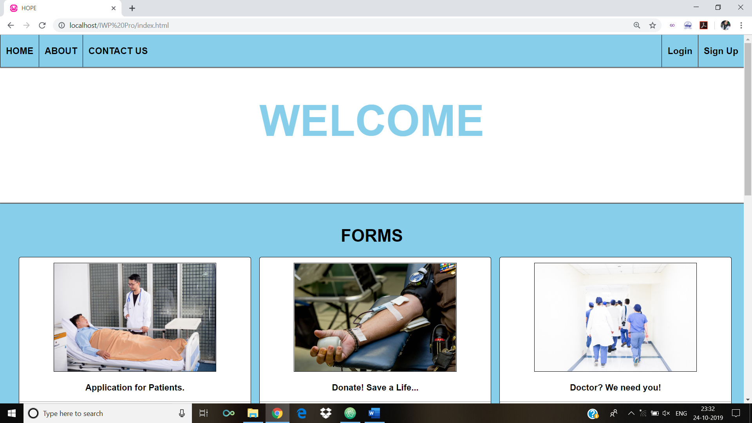

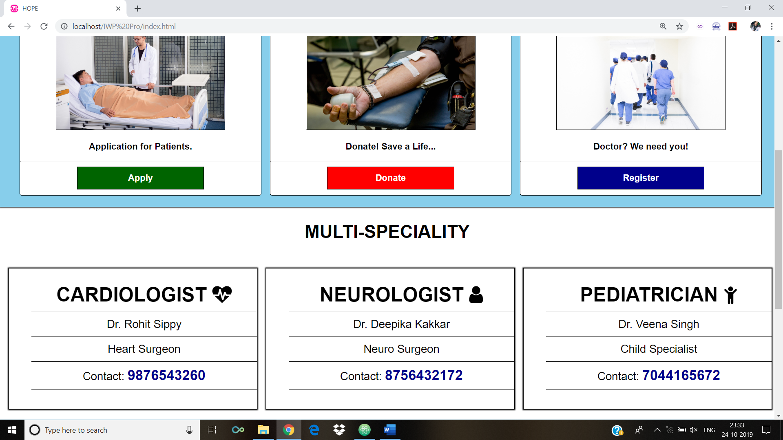

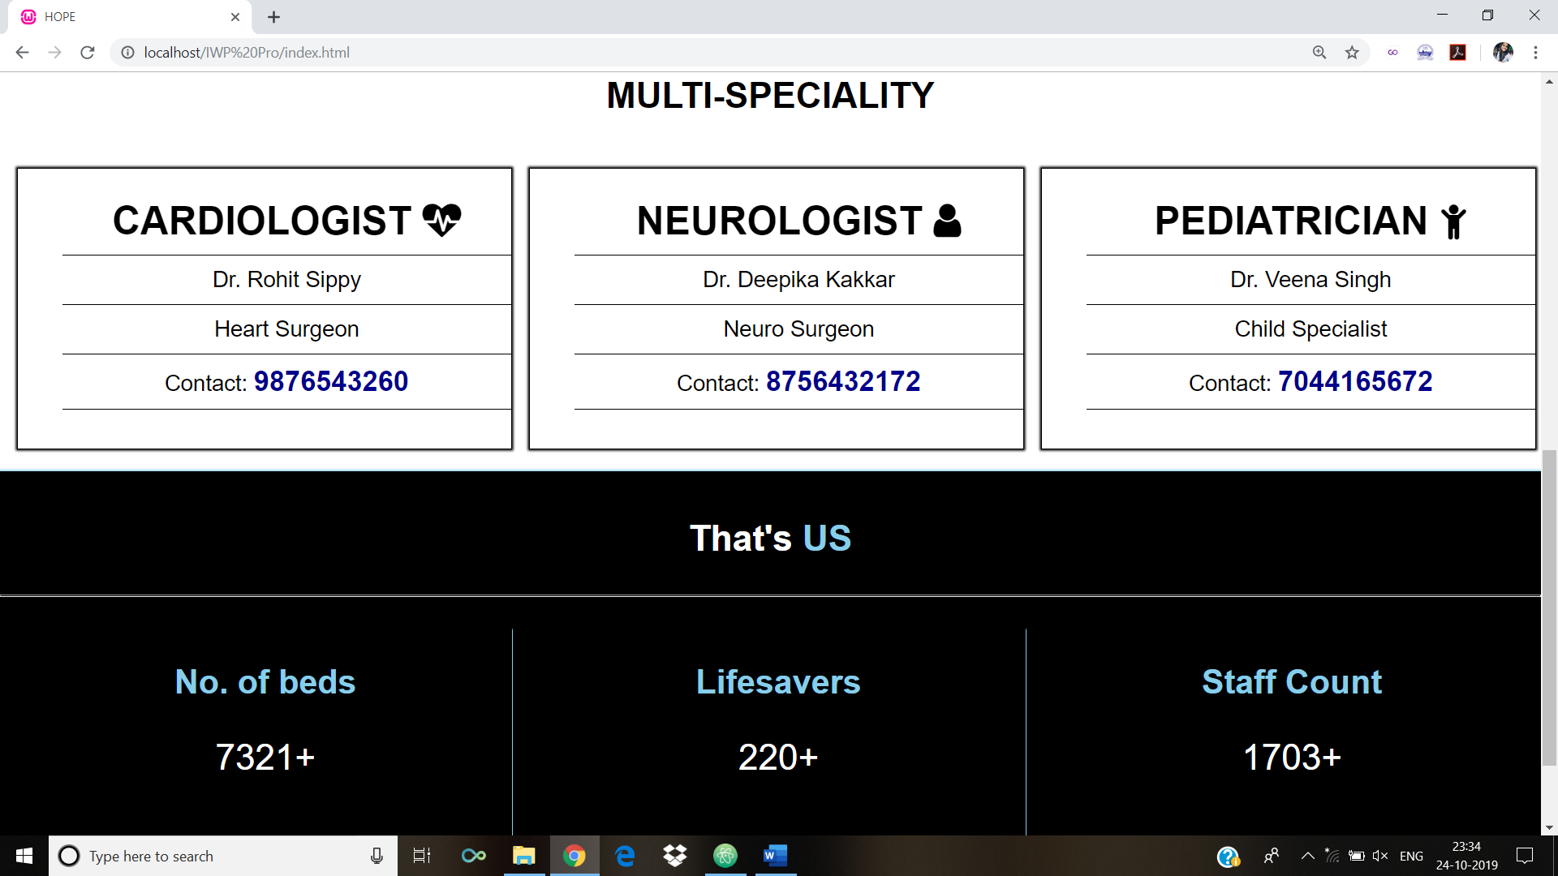

**SIGN-UP PAGE:**

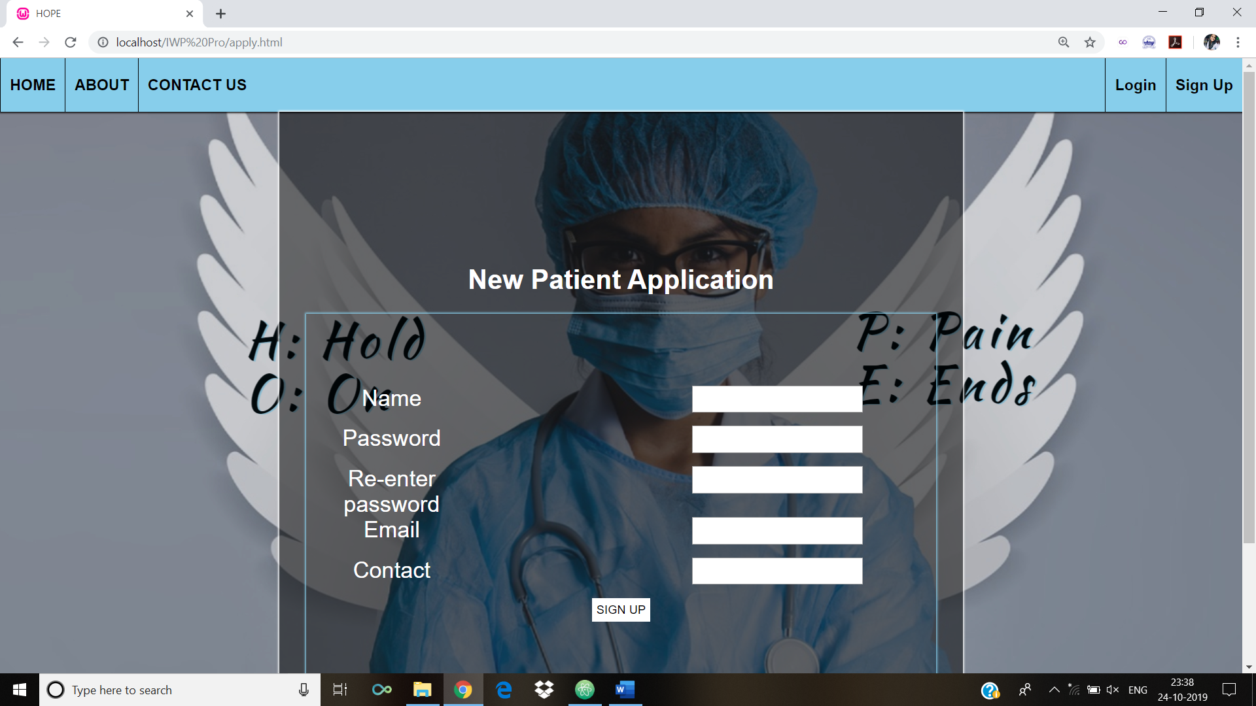

**LOGIN PAGE:**

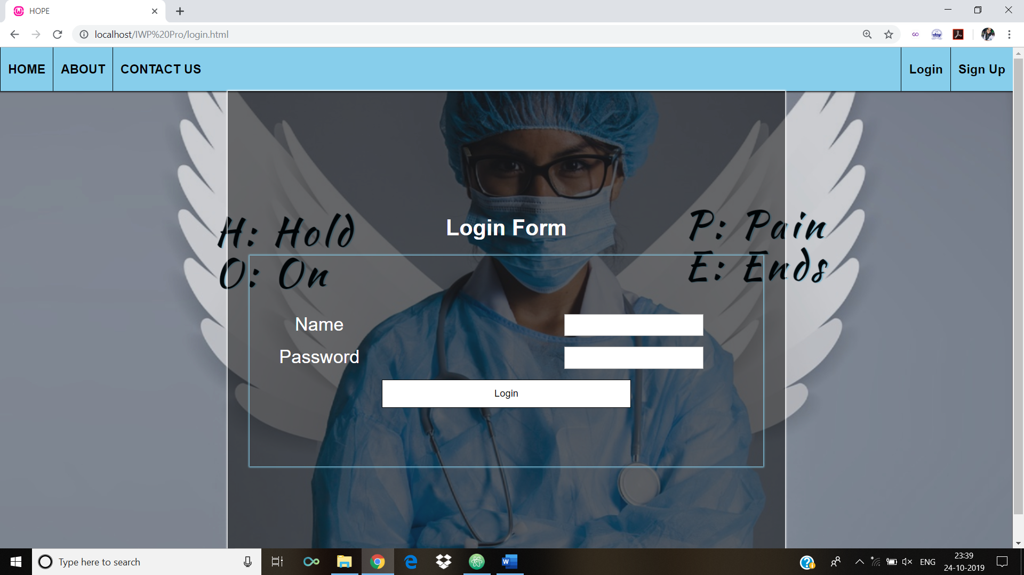

**LOGGED-IN PAGE:**

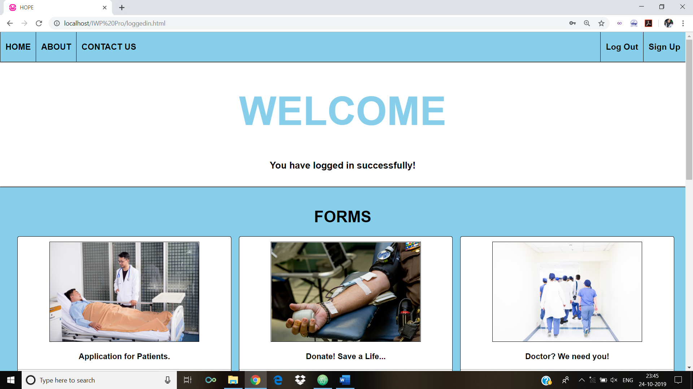

**ABOUT PAGE:**

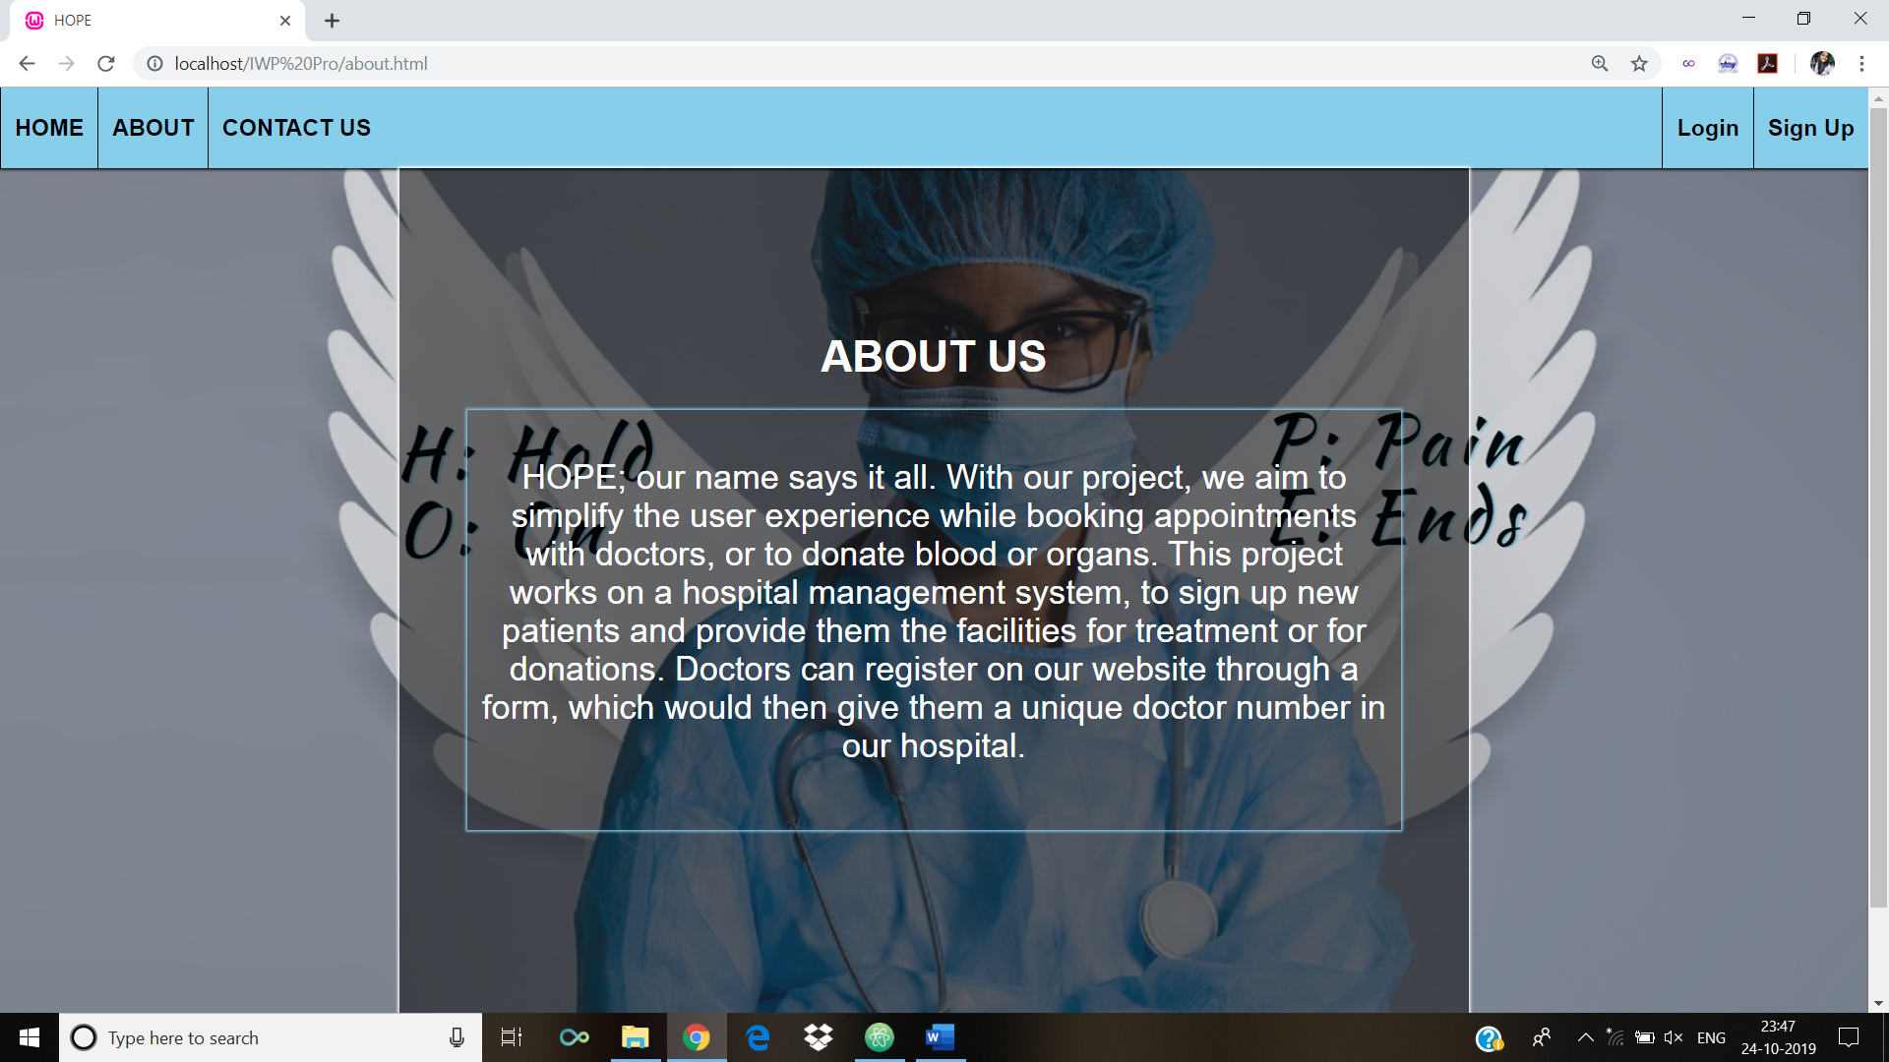

**CONTACT-US PAGE:**

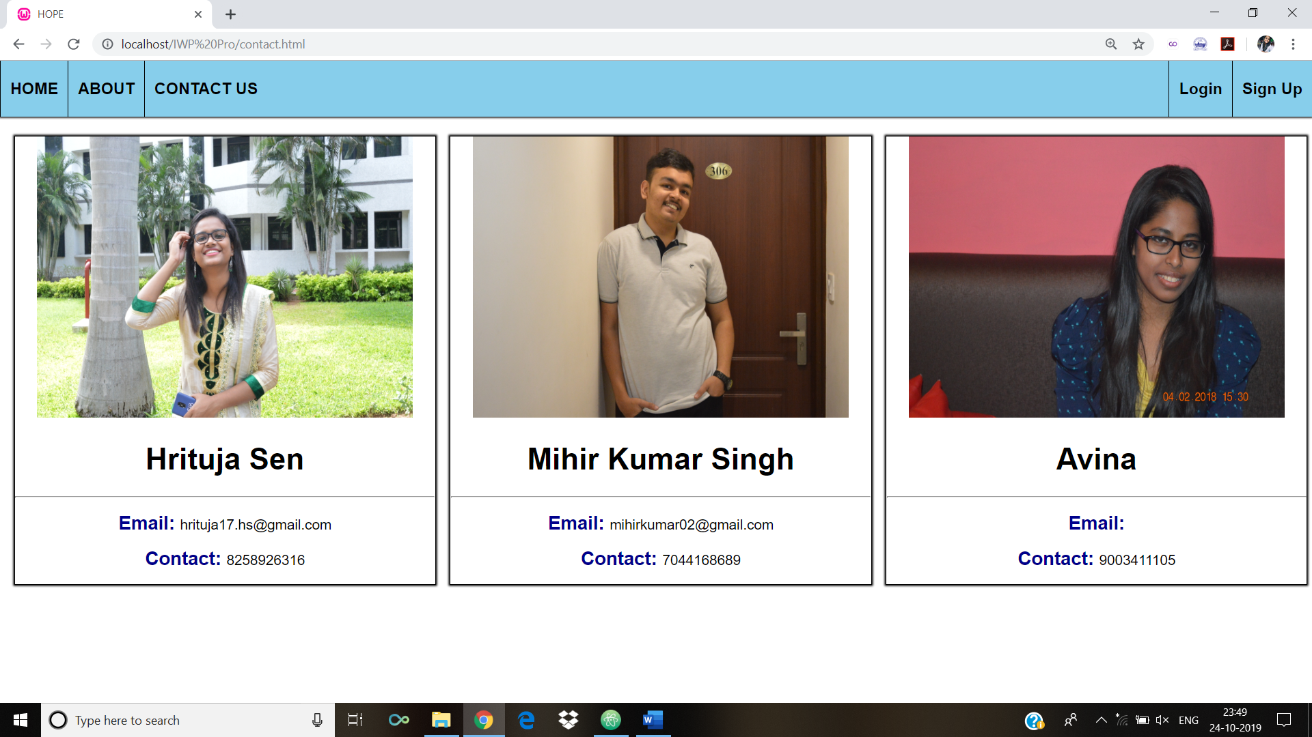

**LOGIN-ERROR PAGE;**

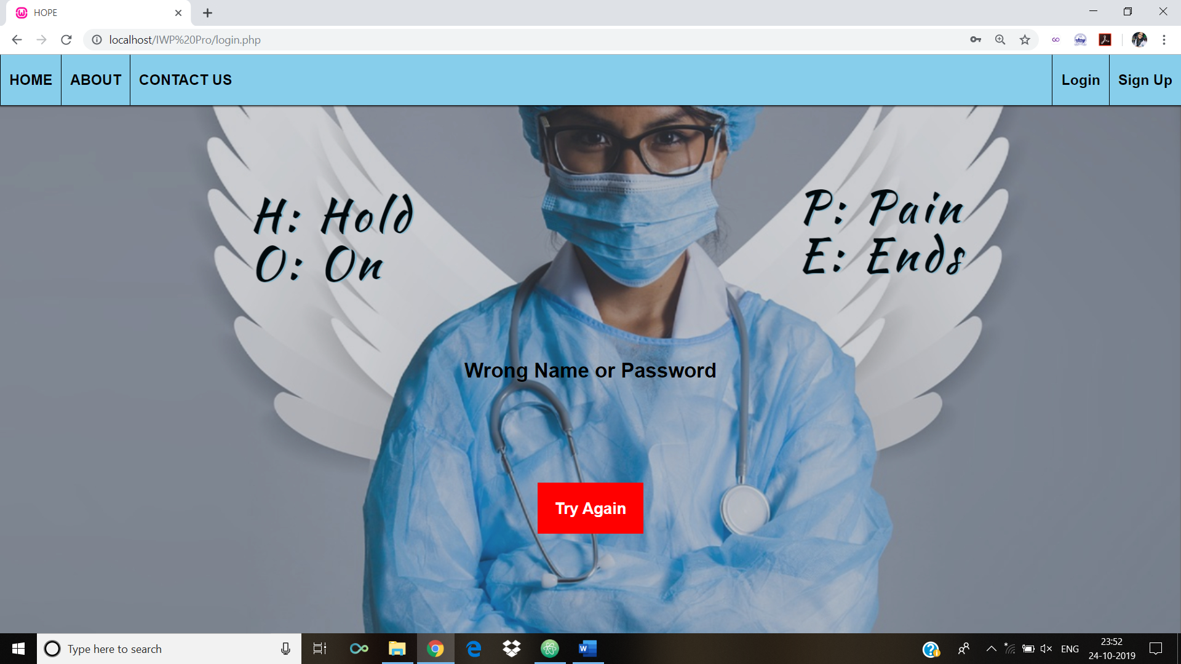

**DONATION FORM PAGE:**

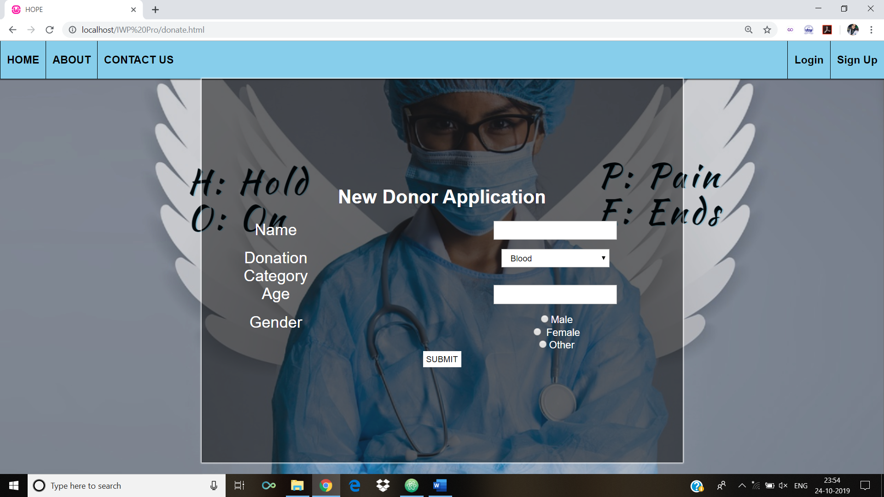

**DATABASE SCREENSHOTS:**

**signup table:**

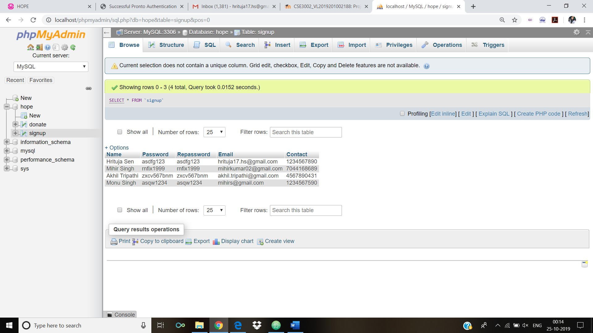

**donate table:**

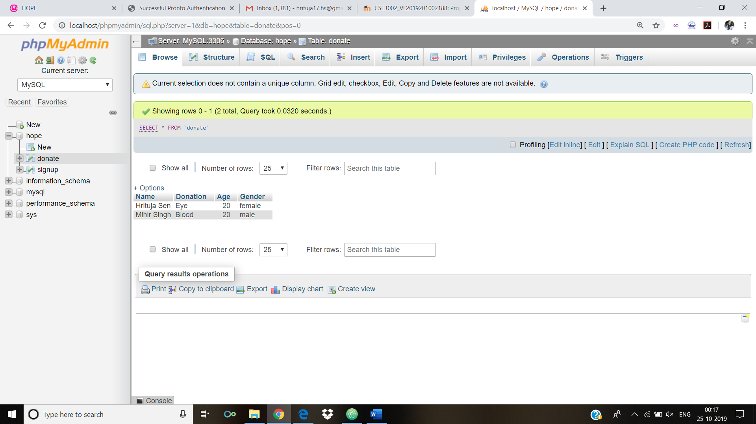

**CONCLUSION:**

This hospital website successfully registers new users into the database and also authenticates their login. The user can either be a patient or a donor or both. Hence, after logging in, the user can fill up the donation form and register as a donor.

The about and contact us pages are small navigation links, which describe the abstract and team members for this project.

Hence, the basic concept of front end UI and backend server programming has been implemented through this project.

THANK YOU